Открытый урок английского языка
в 10 классе
Тема:«Здоровое питание»

Подготовила и провела:
учитель английского языка
ГОУ ЛНР «Ровеньковская гимназия
имени писателя Н.Трублаини»
Протасова М.Ю.

Тема: ЗДОРОВОЕ ПИТАНИЕ
Тип урока: Урок обобщения и систематизации знаний

Цель урока:
Практическая –систематизировать знания по теме «Еда» ,учить употреблять во всех видах речевой деятельности ЛЕ по теме; совершенствовать навыки поискового и просмотрового чтения, формировать активный словарь по теме.
Развивающая – совершенствовать навыки аудирования, монологической речи , говорения, письма; развивать фонематический слух, память, внимание учащихся; развивать способность к самостоятельному поиску и, систематизации информации;
Воспитательная – воспитывать культуру здорового питания. расширять знания о влиянии различных продуктов питания на организм.

Оборудование и ресурсы:
- Компьютер, проектор.
- Презентация к уроку (Healthy Eating)
- Аудиофайлы

Раздаточный материал:
- карточки для учащихся для работы в парах и индивидуальной работы

Формы работы:
- фронтальная, парная, групповая

Ход урока

1. Организационный момент

На экране (презентация):
Tell me what you eat, and I'll tell you what you are.

Приветствие.
- T: Hello, my dear students. I hope you are fine. Take your seats.
Dear guests. We are pleased to see you at our lesson.
Dear students. I’m sure you will be active and friendly today.
Let’s start our lesson.

2. Речевая зарядка
Подготовка учащихся

T: Примерные вопросы к учащимся
- Have you had breakfast?
- What have you had for breakfast?
S: I have had some yoghurt, a sandwich and a cup of tea.
- Well. Thank You.

- And You, .... What have you had for your breakfast?
S: I have eaten some potatoes, an egg and I have had a cup of tea.

T: Look at the blackboard and make up your questions with these words.
Ask your classmates in a chain.

На доске записаны ключевые слова, примеры:
breakfast – What do you usually have for breakfast?
health / (un)healthy – Is your diet healthy or unhealthy?
food/drink – What is your favourite food/drink?
typical – What do you eat in a typical day?
diet – Do you follow a diet?
Примерные вопросы учащихся:
- What do you usually have for breakfast?
- Do you like juice for breakfast?
- Does your mother drink coffee in the morning?
- Do you eat a lot of sweets?
- What fruit and vegetables do you prefer?
- Do you care about your health?
3. Постановка цели и задач урока. Мотивация учебной деятельности учащихся.

1) Постановка проблемной задачи
T: As for me I prefer a cup of tea with sweets for breakfast. But I usually skip my breakfast. I’m not sure that it is good for my health but it becomes a habit.
I would like to measure my body (waistline). Учитель показывает измеритель тела.
Oh, I have got some problems. I think I’m overweight. (I think I’m fatter than I should be.)
Can you give me a piece of advice what I should eat or shouldn’t eat?
S: Have you thought about eating less / taking regular exercise?
(учащиеся отвечают по цепочке, учитель благодарит за ответ)
T:
- That’s a good/nice idea.
- Thanks, I’ll try it.
- I’m not sure if it will work.
- Maybe you are right.
- I have already tried that and it didn’t work.

2) People say that you are what you eat. Let’s have a look at the screen. There are some delicious, colorful things, aren’t there?
Can you guess what the topic of our lesson is? What are we going to talk about?
(ответы учащихся) ...Yes, You are right, we are going to speak about healthy eating habits.

Today we are going to learn how to:
- talk about food and health
- ask about health
- advise and agree or disagree

4. Повторение и обобщение ранее изученного материала, в том числе определенных понятий и фактов

1) Тест (устно). Quiz: Rainbow of food

We should have healthy eating habits. They can prevent us from getting ill. A fun way to stay healthy is to follow a rainbow diet.
Look at the screen and tell me, which colour food should we eat in these situations.
Учащиеся отвечают на вопросы:
Which colour food should you eat if ...
1. You have a difficult exam to study for? 1- orange
2. You are feeling very nervous? 2- green
3. You are worried about getting lines and wrinkles? 3- purple
4. You’ve been feeling a bit sad lately? 4- yellow
5. You are taking part in a championship? 5- red

Примерные ответы учащихся (в полной форме):
1. If I have a difficult exam to study for I should eat – orange foods like mangoes, oranges, peaches, carrots, pumpkins...
2. If I am feeling very nervous I should eat - green foods like brocolli, lettuce, cucumbers.
3. If I’m/you are worried about getting lines and wrinkles I/you should eat - purple foods like plumps, grapes, beetroot, ...
4. If You’ve been feeling a bit sad lately you should eat - yellow foods like/such as bananas, lemons, pineapples...

T: Well, I agree with you. The colors of food influences on our feelings and how we look.
I think eating a rainbow diet is a good idea.

2) Работа в парах (ученики выбирают карточки с проблемой, которую нужно обсудить в виде микро-диалога)
T: Do you care about your health?
If we eat unhealthy food we will get some problems.

Choose a card, please. Imagine you have one of the problems. Discuss them in pairs. Give advice and respond to it. You can use the language box.

Примерные ответы учащихся:

A: I’m underweight!
B: Don’t you think you ought to eat at least three well-balanced meals a day?
A: It’s a nice idea, but I’m not sure if it’ll work.

A: I suffer from a lack of concentration!
B: You might feel better if you eat more ironrich foods.
A: Maybe you’re right, but I don’t really like vegetables!

A: I’m always so tired!
B: You might feel better if you follow a low-carbohydrate diet.
A: That’s not a bad idea.

A: I’ve got toothache.
B: If I were you, I’d cut out sugary drinks and snacks and visit the dentist.
A: Maybe you’re right.

A: I seem to get ill very often! / I’m always catching colds.

B: You might feel better if you eat foods that are rich in vitamin C such as oranges or peaches.
A: Thanks. I’ll try it.

A: My skin is so dry these days!
B: It might be a good idea to drink more water.
A: That’s not a bad idea.

T: Now I see that you know how to advise and respond to it. I hope you will never suffer from any of these problems.

5)Релакспауза (Работа с кроссвордом)

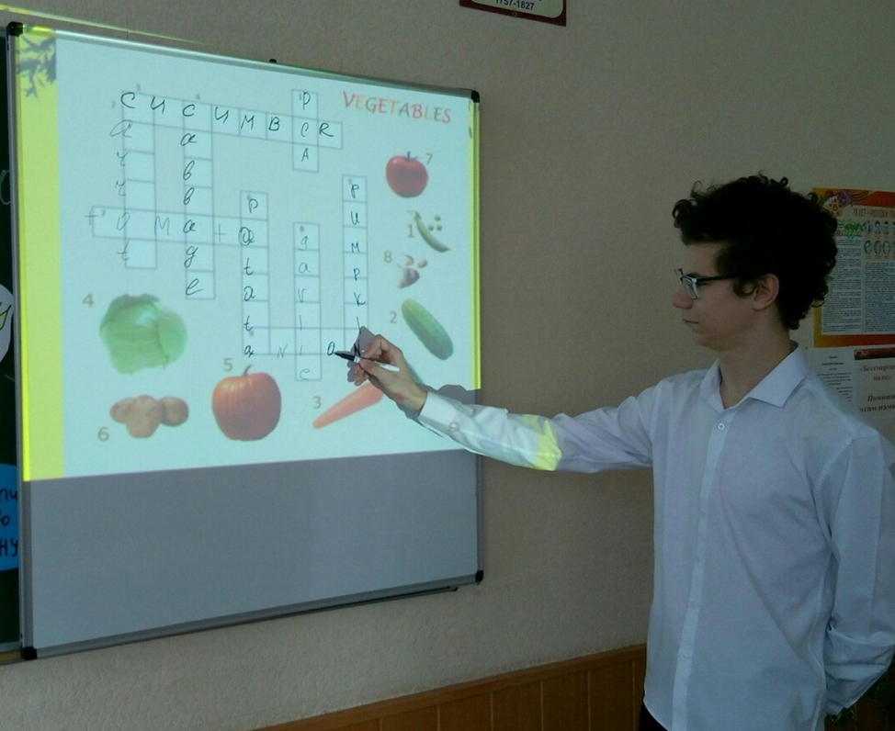

6) Аудирование. Обсуждение

Let’s listen to their stories. Whose opinion do you share?
... прослушивание
Whose opinion do you agree with? Kate’s or Eddy’s ?
Who needs to diet? What is a diet for you? What is your opinion?

примерные фразы для выражения своего мнения:
I agree with... (this opinion)
... says that...
I can’t agree with...
As for me...
Being healthy for me...
Thank you. Now I see how you can express your opinion about eating habits.

7. Развитие монологической речи (Высказавания учащихся «Свое мнение о здоровом питании»)

8.Чтение текста(работа с учебником)с.107

9.Выполнение заданий по содержанию текста

10. Письмо .Работа с карточками

11.Информация о домашнем задании. (написание эссе «за и против»по теме урока)

12. Подведение итогов
Составление кластера по теме урокаурока

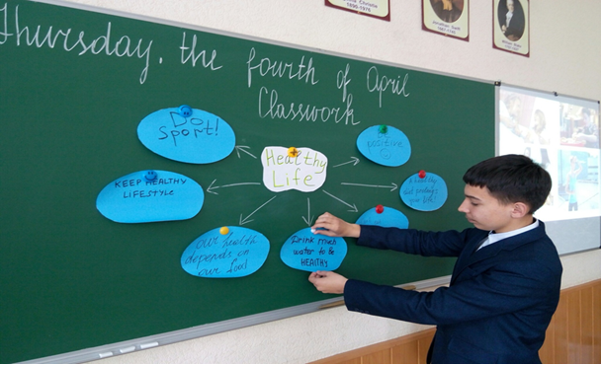

Рефлексия: проверка психоэмоционального состояния учащихся, эффективности мотивации деятельности (попросить учащихся поделиться своими впечатлениями – что было полезным, новым, интересным на уроке и т.п.)
Обсуждение высказывания на экране – как ученики его понимают, какие выводы в ходе урока сделали для себя: Tell me what you eat, and I'll tell you what you are.

T: Dear boys and girls. We have done a lot today. And we have come to the conclusions about healthy eating habits. We all know that well-balanced food plays an important role in our life.
You were active and friendly. Thank you for your work. Now the lesson is over. You may go. Have a nice day.

